



**Functional Design**

**Project Integration 2019-2020**

*Authors: D. Rangelov, A. Belyakov,* *Y. Chen,* *T. Cao, J. Qazi*

*Tutors: R. Kirmali, J.S.D Stokkink, U.Guler*

*Version: 2.0*

|  |
| --- |
| **Saxion University of Applied Sciences** |
| WEEK 1 VHDL |
| VHDL 2018-2019 |
|  |
| **Author : Dimitar Rangelov Student number 445392** |
| Tutor: J.S.D. Stokkink |

Version 0.0.1

**Names and Addresses**

|  |  |  |  |
| --- | --- | --- | --- |
|  | **Arsenii Belyakov** | 450835 | 450835@saxion.nl |
|  | **Dimitar Rangelov** | 445392 | 445392@saxion.nl |
|  | **Tianru Cao** | 454286 | 454286@saxion.nl |
|  | **Junaid Qazi** | 443406 | 443406@saxion.nl |



**Contents**

1. Introduction **Error! Bookmark not defined.**

1.1 Introduction to project 3

1.2 Overview of document 3

2. Analysis of requirements **Error! Bookmark not defined.**

3. Concept Principles 9

3.1. Description of alternative concepts 9

3.2. Comparison of concept principles 11

3.2.1 Functional requirements 11

3.2.2 Technical requirements 11

3.3 Choice of most promising concept principle 12

3.3.1 Environment awareness and setup 12

3.3.2 Call doctors and nurses 12

3.3.3 Human health monitoring 12

3.3.4 Assistant in daily life and affairs 12

3.3.5 Health advice 13

4. Elaboration of chosen principle to functional design 14

4.1 Overview of functional design 14

4.2 Elaboration of functional design 16

4.2.1 Mechanical 16

4.2.2 Electrical 17

4.2.3Electronic 18

4.2.4. Software 20

4.3 Functional Design Integration 24



**1.** **Introduction**

## 1.1 Introduction to project

The purpose of this document is to use the requirements, that were defined in the previous document, and use these requirements to create different concepts.  
Afterwards these concepts are compared based on different parameters and one final concept is chosen.  
In the end the final concept is described in more detail.

**Scope**   
The assignment for ‘Project Integration’ is to create a ‘healthcare robot’ which can assist in certain tasks for a target group that will be chosen by the project members themselves.  
Project integration is a project that lasts two modules, or one semester, and will start at the beginning of quarter 3 and will last till the end of quarter 4.

The “Healthcare system“ for Project integration is consisting of two main devices – smart watch and mother device (healthcare robot). The smart watch will have several sensors that will measure the heart beat and temperature eventually. Also will have gyroscope to follow if the elder people did not drop on the floor. There is a button for SOS and if there is an emergency situation can be pressed and there will be signal. At the same time the healthcare robot will follow the schedule of the client for his/her pills. And will make notification of her/his watch if the time for their pills is. Everything will be user-friendly and easy going adapter to the target group.

## 1.2 Overview of document

This document defines the functional side of the project. The report consists of 3 main chapters that are really clearly describing the functionality of every device in the whole system.  
The first chapter is analysing the requirements. Is separated in two parts because there are two main devices – watch and the mother device. Every device has functionality part and technical (solution) part.  
The second chapter is concept principles and in this part is describing alternative concept principles and they are evaluated against functional and technical requirements.  
The third chapter is describing the two most valuable concepts.



**2. Analysis of requirements**

In the previous report the system requirements were defined.  
Based on these requirements key-parameters are chosen and in the next section different solutions for each key-parameter will be evaluated.  
Eventually all key-parameters will have multiple solutions, each with a different grade based of a certain criterion.

Key-parameters are the fundament of a concept, they define which basic functions the concepts will need to work according to the requirements.

There are ten main key-parameters:

**Topology**: Process used to describe the connections between different systems

**Processing Unit**: Object that is central to all components, it is used to process all incoming and outgoing data while also doing the necessary calculations.

**Power**: Method which is used to power the system.

**Display**: Mechanism used to show data

**Programming Language**: Method which is used to program the system.

**Fall Detection**: Mechanism used to monitor whenever the system is dropped

**Heartbeat Monitoring**: Mechanism used to monitor heartbeats.

**Movement**: Mechanism used to perform certain movements within the system.

**Storage**: Method used to storage different data from the system.

**Communication**: Method used to communicate between different systems

|  |  |  |  |  |
| --- | --- | --- | --- | --- |
| ***Key-parameters*** | **Concept 1** | **Concept 2** | **Concept 3** | **Concept 4** |
| **Topology** | Ring | Mesh | Star | Bus |
| **Processing Unit** | FPGA | Microcontroller | PLC | Personal Computer |
| **Power** | Battery | Wall power | Solar |  |
| **Display** | Oled | E-paper | 7-segment | LCD |
| **Programming Language** | Embedded C | VHDL | PLC | MicroPython |
| **Fall detection** | Accelerometer | Gyroscope |  |  |
| **Heartbeat monitoring** | Photoelectric | Infrared Pulse | Cardiac Signal Sensor |  |
| **Movement** | DC Brushless | DC Brushed | Servo | Stepper Motor |
| **Storage** | SD | MicroSD | Hard Disk Drive | Solid State Drive |
| **Communication** | Wifi | Bluetooth | LAN |  |

Table 1: All key-parameters with different concepts

## 2.1 Comparing Key-parameters Concepts

After defining all key-parameters and giving different concepts that can be used to implement these key-parameters into the design, the concepts will be compared based on certain criteria.

|  |  |  |  |  |  |  |
| --- | --- | --- | --- | --- | --- | --- |
| *Processing Unit* | **Processing Speed (40%)** | **Memory**  **(20%)** | **Size**  **(10%)** | **Ease of Use**  **(10%)** | **Price**  **(20%)** | **Total** |
| **FPGA** | ++ | -- | - | - | + | - |
| **Microcontroller** | + | + | ++ | ++ | ++ | ++ |
| **PLC** | + | + | -- | -- | - | - |
| **Personal Computer** | ++ | ++ | -- | -- | -- | - |

Table 2: Processing unit concepts graded based on certain criteria

|  |  |  |  |  |  |
| --- | --- | --- | --- | --- | --- |
| *Topology* | **Speed**  **(20%)** | **Price**  **(20%)** | **Robustness**  **(40%)** | **Troubleshooting**  **(20%)** | **Total** |
| **ing** | **+** | **++** | **-** | **--** | **-** |
| **Mesh** | **+** | **+** | **+** | **++** | **+** |
| **Star** | **++** | **-** | **+** | **++** | **+** |
| **Bus** | **+** | **++** | **--** | **+** | **-** |

Table 3: Topology concepts graded based on certain criteria

|  |  |  |  |
| --- | --- | --- | --- |
| *Power* | **Capability**  **(50%)** | **Portability**  **(50%)** | **Total** |
| **Battery** | + | ++ | ++ |
| **Wall power** | ++ | -- | - |
| **Solar** | + | - | - |

Table 4: Power concepts graded based on certain criteria

|  |  |  |  |  |
| --- | --- | --- | --- | --- |
| *Display* | **Power Usage**  **(40%)** | **Resolution**  **(40%)** | **Price**  **(20%)** | **Total** |
| **Oled** | **+** | **++** | **+** | **+** |
| **E-paper** | **++** | **+** | **--** | **+** |
| **7-segment** | **+** | **--** | **++** | **-** |
| **LCD** | **+** | **-** | **+** | **-** |

Table 5: Display concepts graded based on certain criteria

|  |  |  |  |  |
| --- | --- | --- | --- | --- |
| *Programming Language* | **Speed**  **(30%)** | **Ease of use**  **(20%)** | **Compatibility**  **(50%)** | **Total** |
| **Embedded C** | **+** | **++** | **++** | **++** |
| **VHDL** | **++** | **-** | **-** | **+** |
| **PLC** | **+** | **--** | **--** | **--** |
| **MicroPython** | **+** | **++** | **++** | **++** |

Table 6: Programming language concepts graded based on certain criteria

|  |  |  |  |  |
| --- | --- | --- | --- | --- |
| *Fall Detection* | **Accuracy**  **(50%)** | **Speed**  **(30%)** | **Cost**  **(20%)** | **Total** |
| **Accelerometer** | **+** | **++** | **+** | **++** |
| **Gyroscope** | **+** | **++** | **+** | **++** |

Table 7: Fall detection concepts graded based on certain criteria

|  |  |  |  |  |  |
| --- | --- | --- | --- | --- | --- |
| *Heartbeat Monitoring* | **Accuracy**  **(30%)** | **Speed**  **(20%)** | **Portability**  **(30%)** | **Ease of implementation**  **(20%)** | **Total** |
| **Photoelectric** | - | + | ++ | ++ | + |
| **Infrared Pulse** | ++ | + | - | -- | - |
| **Cardiac Signal Sensor** | + | + | -- | -- | -- |

Table 8:Heartbeat monitoring concepts graded based on certain criteria

|  |  |  |  |  |
| --- | --- | --- | --- | --- |
| *Movement* | **Accuracy**  **(40%)** | **Torque**  **(20%)** | **Price**  **(40%)** | **Total** |
| **DC Brushed** | -- | ++ | + | - |
| **DC Brushless** | - | ++ | -- | - |
| **Servo** | + | - | ++ | + |
| **Stepper Motor** | ++ | + | -- | + |

Table 9: Movement concepts graded based on certain criteria

|  |  |  |  |  |
| --- | --- | --- | --- | --- |
| *Storage* | **Speed**  **(40%)** | **Size**  **(40%)** | **Price**  **(30%)** | **Total** |
| **SD** | **-** | **+** | **+** | **+** |
| **MicroSD** | **-** | **++** | **+** | **+** |
| **HDD** | **+** | **--** | **-** | **--** |
| **SSD** | **++** | **--** | **-** | **-** |

Table 10: Storage concepts graded based on certain criteria

|  |  |  |  |  |
| --- | --- | --- | --- | --- |
| *Communication* | **Speed**  **(40%)** | **Stability**  **(30%)** | **Portability**  **(30%)** | **Total** |
| **Bluetooth** | - | - | ++ | - |
| **Wifi** | + | + | ++ | ++ |
| **LAN** | ++ | ++ | -- | + |

Table 11: Communication concepts graded based on certain criteria



**3. Concept Principles**

## 3.1. Description of alternative concepts

In the following section four different concept-ideas will be shown in a morphological table.

|  |  |  |  |  |
| --- | --- | --- | --- | --- |
| *Key-parameters* | **Concept Idea 1** | **Concept Idea 2** | **Concept Idea 3** | **Concept Idea 4** |
| **Topology** | **Mesh** | **Star** | **Ring** | **Bus** |
| **Processing Unit** | **FPGA** | **Microcontroller** | **PLC** | **PC** |
| **Power** | **Wall Power** | **Battery** | **Solar** | **Wall Power** |
| **Display** | **E-paper** | **OLED** | **LCD** | **7-segment** |
| **Programming Language** | **VHDL** | **MicroPython** | **PLC** | **Embedded C** |
| **Fall Detection** | **Accelerometer** | **Gyroscope** | **Gyroscope** | **Accelerometer** |
| **Heartbeat Monitoring** | **Infrared Pulse** | **Photoelectric** | **Cardiac Signal Sensor** | **Infrared Pulse** |
| **Movement** | **DC Brushed** | **Servo** | **DC Brushless** | **Stepper Motor** |
| **Storage** | **SD** | **MicroSD** | **HDD** | **SSD** |
| **Communication** | **Bluetooth** | **Wifi** | **LAN** | **LAN** |

Table 12: Morphological diagram displaying four different concept ideas

## 3.2. Comparison of concept principles

In the following section all concept ideas will be compared and given an average score.  
The score is based on the key-parameters that were given a grade in the previous chapter.  
The maximum grade is a 4, which equals to ++ in the previous chapter, while the minimum grade is a 1, which equals to -- in the previous chapter.

There are four concept ideas:

**Concept Idea 1**: Mesh, FPGA, wall power, E-paper, VHDL, accelerometer, infrared pulse, DC brushed, SD, Bluetooth

*Average score of all key-parameters:* ***2.5/4 (+)***

**Concept Idea 2**: Star, microcontroller, battery, OLED, MicroPython, gyroscope, photoelectric, servo, microSD, Wi-Fi

*Average score of all key-parameters:* ***3.5/4 (++) Highest average***

**Concept Idea 3**: Ring, PLC, wall power, LCD, PLC, gyroscope, cardiac signal sensor, DC brushless, HDD, LAN

*Average score of all key-parameters:* ***1.8/4 (-) Lowest average***

**Concept Idea 4**: Bus, PC, solar, 7-segment, embedded C, accelerometer, infrared pulse, stepper motor, SSD, LAN

*Average score of all key-parameters:* ***2.7/4 (+)***

## 3.3 Choice of most promising concept principle

In the previous section four different concept ideas were chosen and afterwards compared.  
From these four concepts, **concept idea 2** scored got the highest average grade and seems to be the most promising and thus is chosen as the final concept.  
There main reasons why concept idea 2 was chosen are:

* Easy to implement: all concepts of idea 2 were relatively easy to implement into both the watch and the main device.
* Availability: All concepts of idea 2 are relatively easy to get.
* Functionality: Concept Idea 2 fulfils all requirements from the client.

In the following section the choices for all key-parameters are further elaborated on.

### 3.3.1 Topology

The star structure is chosen for the topology key-parameter.  
The structure works best within the two systems and seems to be the most effective in the scenario in which the system will work.

### 3.3.2 Processing Unit

The choice for the processing unit was a **microcontroller**.  
The reason for this is the fact a microcontroller provides enough processing speed, memory and is relatively easy to program.  
Furthermore it is compact enough to work on both the main device and the watch while being relatively cheap.

### 3.3.3 Power

The power key-parameter can be split into two parts: main device and smartwatch.  
The choice for the main device is **wall power**.  
The reason behind this is the fact that the main device is stationary.  
Adding a battery to this device would make it impractical.

The choice for the smartwatch is a **battery**  
The reason behind this is the fact that it is a portable device, which means it cannot use wall power.  
Solar is not an option for both devices since there is no space for the size of a solar panel that is big enough to generate enough energy.

### 3.3.4 Display

**OLED** is the best option for the display.  
The reason for this is the fact that OLED has a high resolution, uses a relatively small amount of power and has a fair amount of colours.

### 3.3.5 Programming

**MicroPython** is chosen as the programming language.  
The reason for this is the fact that MicroPython is compatible with most of the parts while also being relatively easy to implement.

**Java** will be used as a programming language for server-client architecture, GUI, connection with the database, etc. The main reason why our team is using java is that it is really simple to work with it and most of the team is really familiar with it.

The database which is going to be used will be **SQL-based database**. We are going to use it, because it corresponds to most of our requests and also simple enough to work with.

### 3.3.6 Fall Detection

For fall detection, there are two choices: accelerometer and gyroscope. Compared with accelerometer, the error of **gyroscope** is much smaller. Moreover, the function of anti-fall is related to the function of rescue, and the accuracy is a very important criterion.

### 3.3.7 Heartbeat Monitoring

The **Photoelectric** sensor is chosen for heartbeat monitoring.  
The reason behind this is the fact that the infrared pulse sensor works best when pressed against the users finger.  
This is not a possibility since the sensor needs to be attached to a watch.  
The other option was a cardiac signal sensor, however this sensor works best when attached to the chest.  
In the end the photoelectric sensor was the best option since it can be placed on the backside of the watch and measure the heartbeat of the user via the wrist.

### 3.3.8 Movement

A **servo** was chosen for the movement key-parameter.  
The reason behind this is the fact that the extra torque from the DC brushed and brushless motors isn’t necessary.  
DC brushed and brushless motors are also not accurate enough.  
A stepper motor could be a good choice, however it is much more expensive and also much bigger.  
In the end the servo is accurate enough while also being reasonably priced.

### 3.3.9 Storage

**MicroSD** is chosen as the storage method.  
The reason behind this is the fact that microSD is small enough to fit on both the main device and the smartwatch.  
It is also much easier to implement into the design compared to a HDD or SSD.

### 3.3.10 Communication

**Wi-Fi** is chosen as the method for communication.  
The reason behind this is the fact that Bluetooth doesn’t provide the range that is necessary for the system to work steadily.  
On the other hand LAN cannot be used since the watch needs to be portable.

The following chapter describes the overall system and the different subsystems of the chosen concept.  
The goal of the chapter is to explain how the chosen concept works as a whole.



**4. Elaboration of chosen principle to functional design**

## 4.1 Overview of functional design

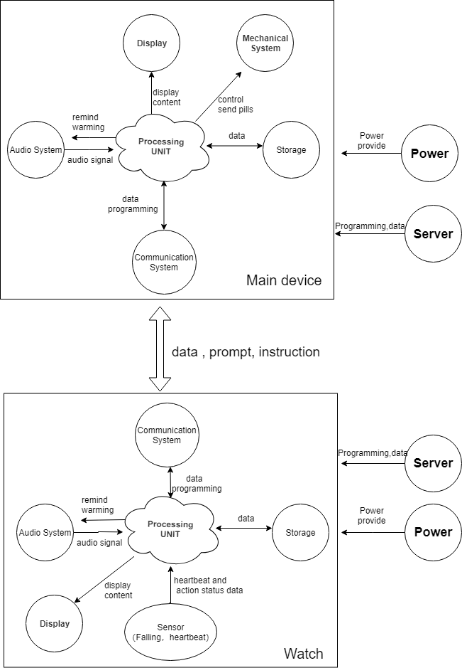

Figure 1: Diagram showing the overview of the functional design as a whole

**Shell**

it shows the outside image of main device.

**Display**

it shows the text ,time and other information. The user can directly see the  information and operation guide provide by the device.

**Medicine distribution**

Uses can set the eating pill time, and main device will provide the need quantity of the medicine on time.(uses should put the medicine in the main device in advance)

**Sound system**

It  is used to get user’s voice and make a sound. Including the function of voice control system, warning reminder and etc.it has micro phone and speaker.

**Microcontroller**

It is the same part in the device. It used to control whole of device , process data and programming.

storage

It is used SD card to store data of software and client information.

**Communication**

It is used to connect to Internet and communicate with watches. It may be used wireless way to connect (Wi-Fi or Bluetooth).

**Connector**

It can connect to PC or power supply with cable or USB.

**Circuit board**

It is the hardware part of main device.it includes whole components to operate main device.

**Power**

It provides the electrical energy to watch.

**Heart beat sensor**

It can read user’s heart rate.

**Falling sensor**

When user has a fall, it can detect this situation. This function is only for old people.

## 4.2 Elaboration of functional design

Now that the system as a whole is shown in a function diagram, the system will be divided into four sub-systems:

* Mechanical
* Electrical
* Electronic
* Software

### 4.2.1 Mechanical

The mechanical function is to provide the appointed medicine and quantity to appointed user. Because of one main device with several users, this design need recognize different users and give appointed quantity of medicine. So ,it should use mechanical device to pop pill-box and use microcontroller to control the time and choose the right box.

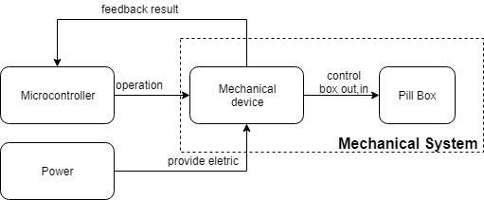

Figure 2: Diagram showing the mechanical functions of the system

### 4.2.2 Electrical

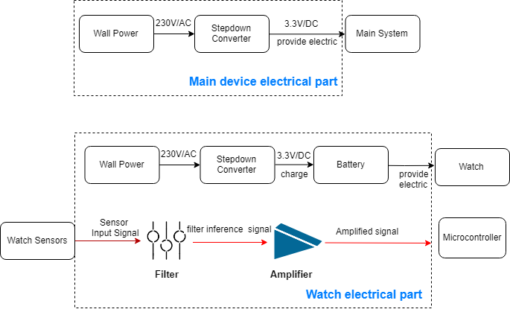

Figure 3: Diagram showing the electrical functions of the system

The electrical part lies on the circuit board including power supply, audio system, filter and amplifier.  
Firstly, for the power supply system, the design will adopt simple way to change urban electricity supply to device’s power supply.  
Secondly, this part’s function is to reach a part of speech recognition function and voice function.  
Because our design has a very important function is intelligent speech recognition, the extraction of human voice is very important. And the frequency of human voice is between 300 ~ 3400Hz and it can be extra by filter part.   
At the same time, the combination of amplifier and speaker can make the sound more clear.

### 4.2.3 Electronic

The electronic functional design will cover all the functions of the device that use any kind of electronics.  
The major difference between electrical and electronic functional design is the fact that electrical is more related to power.  
The electronic functional design can be divided into two parts:

* Smartwatch
* Main Device

#### 4.2.3.1 Smartwatch

The smartwatch will be used to monitor different values of the user and is a vital part of the system as a whole.  
In the following section all electronic design functions of the smartwatch will be discussed and shown in a simple block diagram.  
In figure 4 the main functions of the smartwatch can be seen in a block diagram.  
The smartwatch has six main functions:

1. Processing Unit: Core of the device, performs all calculations
2. Communication: Communication between watch and main device.
3. Storage: Certain data can be stored
4. Fall Detection: Ability to detect whenever the device is dropped
5. Heart Rate Monitoring: Ability to monitor the users heart rate
6. Display: Certain data can be shown on a display

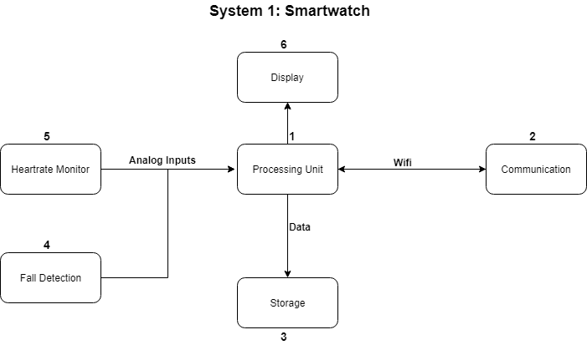

Figure 4: Diagram showing the electronic functions of the first system

#### 4.3.2.2. Main Device

The main device is supposed to be the ‘hub’ of the system as a whole.  
In the following section all electronic design functions of the mother device will be discussed while also shown in a block diagram.  
The main device has six main functions:

1. Processing Unit: Core of the device, performs all calculations
2. Speaker: Ability to use sound to communicate with the user
3. Medicine Distribution:
4. Storage: Certain data can be stored
5. Communication: Communication between watch and main device.
6. Display: Certain data can be shown on a display

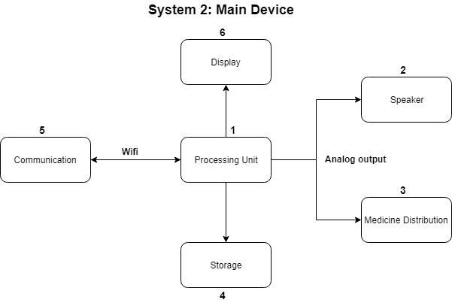

Figure 5: Diagram showing the electronic functions of the second system

### 4.2.4. Software

The software functional design will cover all the functions of the watch that use any kind of software.  
The software functional design can be split into two parts:

* Main functions
* Sub-functions

The difference between the main and sub-functions is the fact that main functions describe software used for functions which are absolutely essential for the system to work.  
Sub-functions are considered to be less essential to the working of the system but having these sub-functions will improve the system as a whole.

#### 4.2.4.1 Main Software Functions

The main functions can be split into three parts:

* Main software functions of the smartwatch
* Main software functions of the mother device
* Main software functions between the smartwatch and mother device

#### 4.2.4.1.1 Main Software Functions smartwatch

In figure 6 the main software functions of the smartwatch are shown.  
The main software functions of the smartwatch can be divided into three functions:

**Function 1: Sensor Data Acquisition**The smartwatch should have the ability to acquire data from the sensors.  
This is a key function since the data acquired from the sensors is the base for other software and hardware functions.

**Function 2: Present Relevant Data on Display**The smartwatch should have the ability to show key information on a display.

**Function 3: Data Logging on External Device**The smartwatch should have the ability to log the data that was previously acquired from the sensors on an external storage device.

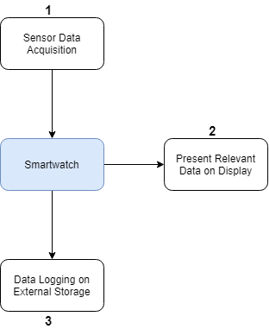

**Figure 6 Simple block diagram representing all main software functions of the smartwatch**

#### 4.2.4.1.2 Main Software Functions Mother Device

In figure 7 the main software functions of the mother device are shown.  
The main software functions of the mother device can be divided into three parts:

* Control the Medicine Distribution
* Data Logging on External Device
* Display Relevant Data on Display

**Function 1: Control the Medicine Distribution**One of the key functions of the mother device is to control the medicine distributions.  
This means controlling some kind of mechanical device like a motor or servo.

#### Function 2: Data Logging on External Device The mother device should have the ability to log data acquired from different parts of the system and store it on an external storage device.

#### Function 3: Display Relevant Data on Display The mother device should have the ability to show key information on a display.

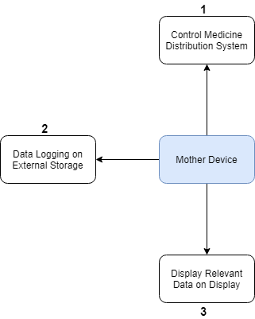

**Figure 7 Simple block diagram representing all main software functions of the mother device**

#### 4.2.4.1.3 Main Software Functions Between Mother Device and Smartwatch

In figure 8 the main software functions between the mother device and the smartwatch are shown.  
The main software functions between the mother device and the smartwatch can be divided into three parts:

* Medicine Intake Reminder
* Medical Emergency Alert
* Medicine Distribution Request

#### Function 1: Medicine Intake Reminder The mother device should have the ability to send a reminder to the smartwatch. This reminder is set by the user and the purpose of this function is to remind the user whenever it's time to consume his or her medicine.

#### Function 2: Medical Emergency Alert The smartwatch should have the ability to send a message to the mother device whenever it detects a medical emergency. Medical emergency detection is done by the smartwatch which uses data acquired from the sensors, which was discussed in the previous chapter.

#### Function 3: Medicine Distribution Request Previously a function that controls medicine distribution from the mother device was mentioned. This function gives the user the correct medicine at the right time However it should interact with the smartwatch to decide the identity of the user to prevent the wrong medicine being given to the wrong person.

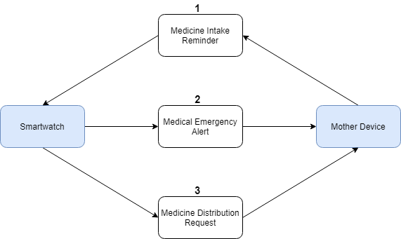

**Figure 8 Simple block diagram representing all main software functions between mother device and smartwatch.**

## 4.3 Functional Design Integration

The functional design integration covers all parts of the functional design that don’t necessary fit into the mechanical, electrical, electronic or software design.  
These might be functions that are unrelated to any of the categories named above but can also be functions that are related to multiple categories at the same time.

The functional design integration can be divided into three parts:

* Maintenance
* Safety
* Accuracy

#### Function 1: Maintenance

Maintenance is an important part of a system, bad maintenance can lead to wear and tear which will affect the functionality of the system.  
The system is considered to be a medical device which means that if the system isn’t functioning the way it is supposed to, there will be major consequences.  
This is why maintenance of the system will be one of the main  functions of the design integration.  
An important thing to keep in mind is that the system will be used commercially, most likely in the home of the user.  
The target group was previously chosen and it was concluded that a majority of the people in the target group are considered to be ‘technologically inept’.

In the end the maintenance should be:

* Easy to perform
* Easy to understand
* Hard to mess up

#### Function 2: Safety

The system is considered to be medical device which means it needs to conform to certain safety standards.  
The system is not an end product which will be produced and sold commercially but more a proof-of-concept.  
This means that not all safety standards for medical devices within the European Union need to be conformed to, which is a good thing since there simply is not enough time to conform to all these standards.  
However safety is still in incredibly important part of the system, mistakes within the product can have major consequences.

This is why safety is considered to be one of the main functions of the design integration.

The system should have the following safety standards:

* The system should not be susceptible by any electromagnetic interference.
* Any mechanical function should not be considered ‘fragile’ or ‘easy to break’
* Any electronic and software function related to the distribution of medicine should be secure enough to prevent that the wrong medicine is given to the wrong person.

#### Function 3: Accuracy

A certain part of the system has a function to monitor the heart rate of the user and a function to detect falls.  
The objective of having these functions is to track the health of the user and notify the authorities whenever an medical emergency takes place.  
The malfunctioning of these functions can have major consequences.  
This is the reason why the accuracy of these functions, in both a software perspective and an electronic perspective, should be good enough to detect whenever an actual medical emergency is taken place.  
The end system should be able to distinguish between an actual medical emergency and a false flag.

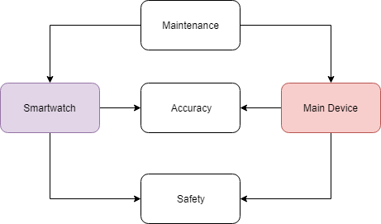

Figure 6: Diagram showing the design integration functions